
Emonti
Optometrist







Optometrist Management System
OptiTech Team
ISTN3SI – MILESTONE 3
Shop 7 New Colonnade,

Devereaux Ave,

Vincent East London 5247
076 463 1930
emontioptom@gmail.com
CLIENT INFORMATION
Client Name: Mr Dlamini and Mr Mayisela
(B. OPTOM UKZN)

Thembelihle Cele (2220345357); Sharon Mokoena (222003624);

Amahle Zungu (222048011); Lindokuhle Mchunu (221070127);

Banele Mathenjwa (222011377)

1. Group and System Details

No | Student Number | Name and Surname | % Contribution | Signature
1 | 222034357 | Thembelihle Cele | 100 | T. Cele
2 | 221070127 | Lindokuhle Mchunu | 100 | L. Mchunu
3 | 222003624 | Sharon Mokoena | 100 | S. Mokoena
4 | 222048011 | Amahle Zungu | 100 | A. Zungu
5 | 222011377 | Banele Mathenjwa | 100 | B. Mathenjwa

2. Front-End System Enhancements

Aspect of Improvement for the Front-End System (FES) | What was done to enhance this aspect of the FES | Level of success (High, Moderate, Low)
Order of Address fields when taking customer information | Re – order the input fields. | High
Payment slip shows R0 for consultation fee but correctly calculates total amount | Fixed method handling for consultation amount | High
Reports | Included payment, customer, inventory reports | High
Soft delete when archiving customer information | This feature has proven to be difficult and beyond the scope of our skills. | High

3. Website Context Level Diagram and Level 0. DFD

3.1 Context Level Diagram

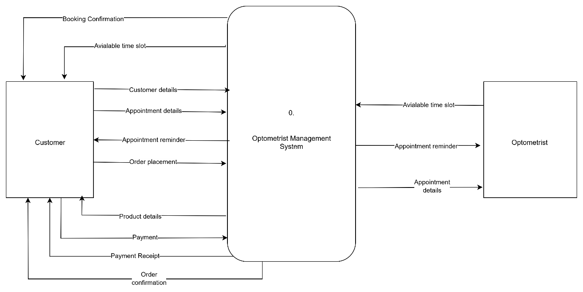

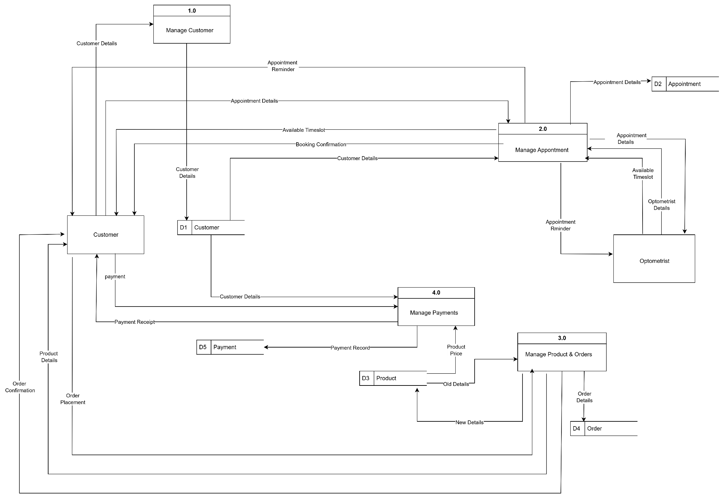

4. Website User Stories

1. Customer
Feature Description | User Profile | Priority | User Story | Acceptance Criteria
Book Appointment | Customer | High | As a customer, I want to book an appointment online so that I can secure a convenient time without calling the practice. | System allows selection of service, date, and available time slot; prevents double bookings; validates mandatory fields; displays error messages for invalid inputs; confirms booking with on-screen and email confirmation; stores appointment in my history.

Feature Description | User Profile | Priority | User Story | Acceptance Criteria
Browse Frames | Customer | High | As a customer, I want to browse the available frames so that I can choose the style and specifications I prefer before purchasing. | System displays frames with images, descriptions, and prices; supports filtering by price range; clicking on a frame shows detailed specifications; displays availability status; loads frame details within 2 seconds for smooth browsing.

Feature Description | User Profile | Priority | User Story | Acceptance Criteria
Browse Lenses | Customer | High | As a customer, I want to browse the available lenses so that I can choose the correct lens type, material, and specifications for my prescription or needs. | System displays lenses with images, descriptions, and prices; supports filtering by price range; clicking a lens shows detailed specifications; shows stock availability; loads product details within 2 seconds.

Feature Description | User Profile | Priority | User Story | Acceptance Criteria
Purchase Frame | Customer | High | As a customer, I want to browse and purchase frames easily so I can complete my order efficiently with clear pricing and payment options. | Customers can view frames with images, descriptions, and prices; filter by type, size, colour, and price range; view specifications and delivery timeline; add to cart; apply promo codes; checkout securely; enter shipping/billing info; receive order confirmation by email and on-screen; order history updates automatically.

Feature Description | User Profile | Priority | User Story | Acceptance Criteria
Purchase Lenses | Customer | High | As a customer, I want to purchase lenses online so that I can complete my order with my preferred specifications and prescription. | System allows selection of lens product with prescription details; validates prescription format; supports coating and tint options; calculates total price based on selections; allows adding to cart and checkout; accepts multiple payment methods; generates order confirmation on-screen and via email; updates order history.

Feature Description | User Profile | Priority | User Story | Acceptance Criteria
Make Payment | Customer | High | As a customer, I want to make secure payments for my orders or consultations so that my transactions are processed quickly and safely. | System allows multiple payment methods (credit/debit cards, medical aid, EFT, etc.); validates payment details; displays total amount; generates payment confirmation receipt; updates order/consultation status to “Paid”; sends confirmation via email and on-screen; stores transaction in payment history.

Feature Description | User Profile | Priority | User Story | Acceptance Criteria
Browse Products | Customer | Medium | As a customer, I want to browse all available products so that I can explore frames, lenses, and accessories in one place before making a purchase. | System displays a full catalogue of products with images, descriptions, and prices; allows filtering by category (frames, lenses, accessories), brand, price range, and colour; loads results within 2 seconds; clicking a product shows detailed specifications and stock status.

Feature Description | User Profile | Priority | User Story | Acceptance Criteria
Browse Products by Category | Customer | Medium | As a customer, I want to browse products by category so that I can quickly find items I’m interested in without scrolling through unrelated products. | System allows customers to select categories (frames, lenses, accessories); displays only products in that category with images, descriptions, and prices; supports additional filtering by brand and price; product details load in under 2 seconds.

Feature Description | User Profile | Priority | User Story | Acceptance Criteria
Purchase Product | Customer | Medium | As a customer, I want to purchase products online so that I can complete my order with all chosen items in a single transaction. | System allows selection of any product with its specifications; validates stock availability; adds selected items to a shopping cart; supports multiple payment methods; generates an order confirmation on-screen and via email; updates customer order history.

Feature Description | User Profile | Priority | User Story | Acceptance Criteria
Collect Spectacles | Customer | Medium | As a customer, I want to collect my spectacles efficiently after being notified they’re ready, with proper verification of my order details and prescription. | Administrator can retrieve order by name, order number, or phone; order details display product specifications, prescription details, and payment status; identity verified before dispensing; adjustments flagged; order status updated; receipt and care instructions given; collection date/time and staff recorded; outstanding balances trigger alerts.

Feature Description | User Profile | Priority | User Story | Acceptance Criteria
View Booking History | Customer | Medium | As a customer, I want to view my appointment history so I can track past bookings and plan future visits. | System displays a list of past appointments in chronological order; shows appointment date, time, type of service, and optometrist’s name; allows filtering by date range; includes quick rebook option for repeat services.

Feature Description | User Profile | Priority | User Story | Acceptance Criteria
Cancel Appointment | Customer | Low | As a customer, I want to cancel my appointment so I can free the slot if I’m unable to attend. | System allows selection of upcoming appointment from a list; prompts confirmation before cancellation; updates appointment status to “Cancelled”; sends cancellation confirmation via email and on-screen; removes the appointment from the optometrist’s schedule; records cancellation in appointment history.

Feature Description | User Profile | Priority | User Story | Acceptance Criteria
Search Products | Customer | Low | As a customer, I want to search for products by name, category, or brand so I can quickly find what I’m looking for. | Search bar accepts keywords and category filters; displays relevant results with images, descriptions, and prices; allows sorting by relevance, price, or popularity; returns search results within 2 seconds.

Feature Description | User Profile | Priority | User Story | Acceptance Criteria
View Product Details | Customer | Low | As a customer, I want to view detailed product information so that I can make informed purchasing decisions. | Clicking a product displays detailed specifications, images, price, stock status, brand, material, and warranty/return policy; loads details within 2 seconds; related products are suggested on the same page.

2. Optometrist
Feature Description | User Profile | Priority | User Story | Acceptance Criteria
Update Timeslot | Optometrist | High | As an optometrist, I want to update my available timeslots | Optometrist can log in and view their schedule.  Optometrist can add, edit, or remove timeslots.  System prevents double-booking by ensuring updated timeslots reflect in real-time.  Customers only see updated availability when booking.

Feature Description | User Profile | Priority | User Story | Acceptance Criteria
Reschedule Appointment | Optometrist | High | As an optometrist, I want to reschedule existing appointments prior to the customer checking in. | Optometrist can select an existing appointment and choose a new timeslot.  System checks new slot availability before confirming.  Customer receives notification of reschedule via email/SMS.  Appointment status updates automatically in both optometrist and customer calendars.

5. Website Design Documents

5.1 Site-Map Diagram
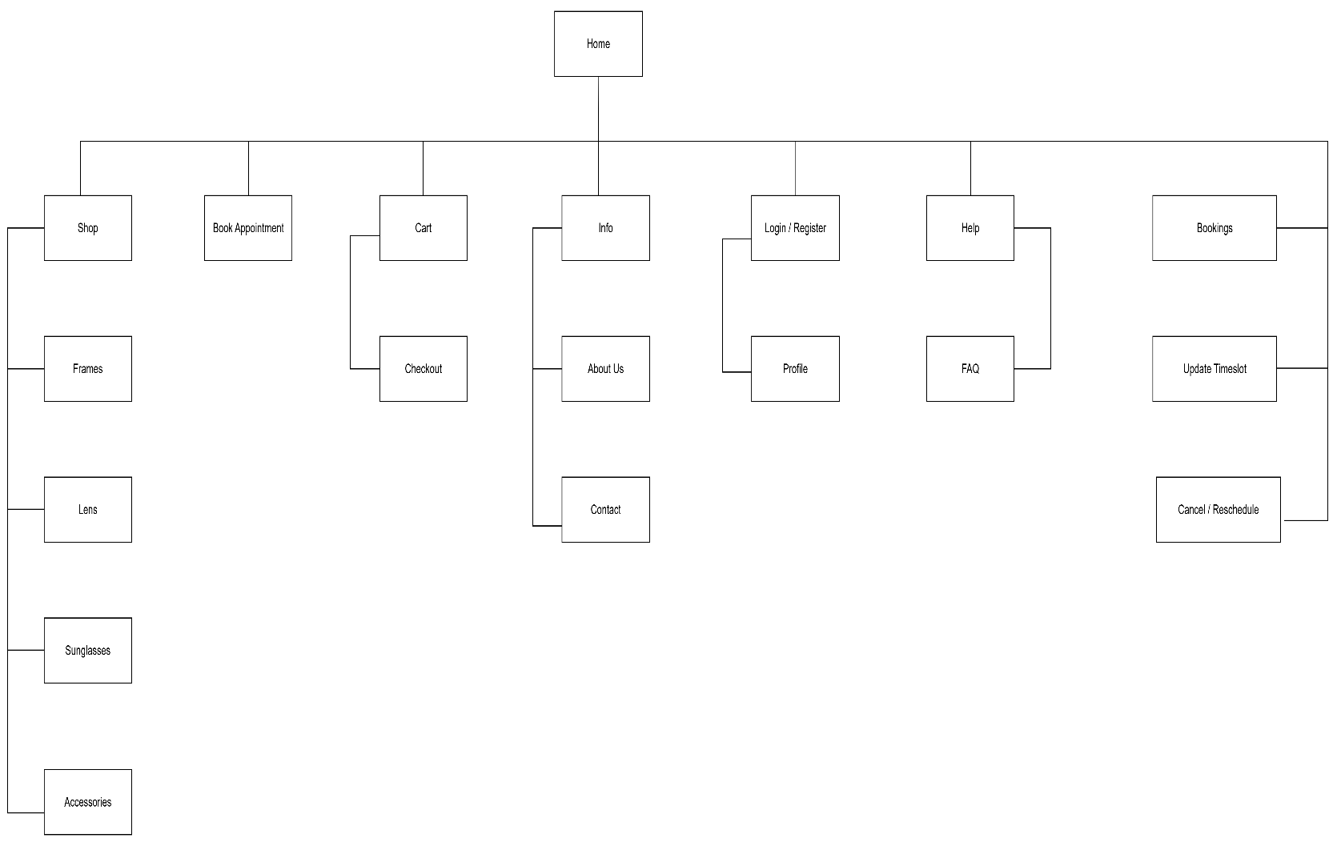
5.2 Page Description Table (PDT)
Page Name | Main Functionality | Sub-functions
Home | Introduces the website and provides quick navigation to key services and products. | Display featured products, promotions, and announcements; quick links to Shop, Eye Tests, and Help; search bar.
Shop | Allows browsing and purchasing of frames, lenses, and accessories. | Browse products by category; filter and sort; view product details; add to cart; apply promo codes.
Book Appointment | Enables booking, viewing, and cancelling appointments. | Book appointment (service, date, time); view appointment history; cancel appointments; rebook option.
Profile | Displays and manages customer account details. | View/edit personal information; order history; payment history; manage saved addresses.
Cart | Manages selected items for purchase. | View cart items; update quantities; remove items; proceed to checkout
Checkout | Facilitates completing the purchase process securely. | Choose payment method; enter billing details; confirm shipping address; review order summary; place order; receive order confirmation.
Help | Provides customer support and information. | FAQs; contact form; live chat or email link; return/warranty policy.
About | Shares company background and mission. | Company history; team profiles; vision and values; certifications and awards.
Contact | Offers ways to reach the business. | Contact form; email address; phone number; store location map; operating hours.
Login | Allows returning customers to securely access their accounts. | Enter username/email and password; forgot password link; validation of credentials; redirect to profile or intended page.
Register | Enables new users to create an account. | Enter personal details, email, password; confirm password; accept terms; email verification link.
Update Timeslot (Optometrist) | Provides optometrist with an option to update their available timeslots. | Add, edit, or delete timeslots; view current availability; prevent double-booking by syncing with appointment system.
Cancel / Reschedule (Optometrist) | Enables the optometrist to cancel or reschedule existing appointments prior to the customer checking in. | Search appointment; select appointment to modify; reschedule to new slot; cancel with reason; notify customer of changes.

6. Website Security

The Optometrist Management System will adopt a simplified yet effective security strategy suited to a small-scale website environment.
- Authentication and Authorization
  - The system will use strong password enforcement to protect both customer and staff accounts.
  - Database role-based access control will be applied so that customers can only access their own profiles and orders, while staff and administrators will have role-specific privileges to manage appointments.
- Database Security
  - The database will enforce least privilege access by assigning different roles to customers, staff, and administrators.
  - Parameterized queries will be used to protect against SQL injection attacks.
- Application Security
  - Input validation and output sanitization will be used to prevent cross-site scripting (XSS).
  - CSRF protection tokens will be applied to sensitive operations such as booking appointments and completing purchases.
  - Session cookies will be protected with HttpOnly, Secure, and SameSite attributes to safeguard against hijacking.
- E-Commerce Security
  - Shopping sessions will be managed securely with timeouts to prevent misuse.
  - Customers will only see their own order history, while staff will have controlled access to manage products and sales.
  - Payments will be processed via a trusted third-party provider, avoiding direct storage of card details on the website.
- Compliance and Privacy
  - The system will comply with POPIA and other relevant data protection standards, ensuring lawful handling of personal and medical details.
  - Customers will be informed through a privacy policy about how their information is used and protected.

7. Website Usability Strategy

The usability strategy applied to our web site attempts to guarantee that the users will be able to accomplish their tasks effectively and with a significant portion of satisfaction. The user interface design process has been built on robust usability principles by Nielsen (2020), Shneiderman (2016), Tognazzini (2014), Stanford Usability Guidelines (2018), and Ramotion (2019).
1. Unity and Norms
We shall also ensure that the navigation menus, the fonts and the colour patterns are the same on every page to limiting cognitive load, adhering to the principle of design predictability and consistency and standards as proposed by Nielsen (2020) and Tognazzini (2014) respectively.
2. System Status visibility
The site will also present instantaneous feedback following each user action considered booking an appointment, adding a product to the shopping cart and so on, through the use of loading indicators, progress indicators and confirmation messages. This goes in line with the first golden rule of Shneiderman (2016) requiring to aim to be consistent in its consistency and keep the users informed, and the principle of visibility of the system status by Nielsen (2020).
3. System/Real-World Match
Labels on the navigation, product categories, as well as the help content will be written in terms that people can understand and not with technical terms. This is in line with the Nielsen (2020) heuristics of the Match Between the System and the Real World and Stanford Usability guidelines (2018) about the importance of the language that fits the expectations of users.
4. Freedom and Control in the hands of the user
Such important steps like entering an order or booking an appointment will have a Cancel and Undo button which will enable recovering erroneous processes. This strategy complies with the Nielsen (2020) principle of User Control and Freedom and the advice by Tognazzini (2014) to have an option of reversing action easily.
5. Error Prevention and recovery
The forms will have real-time validation, understandable and constructive error messages to avoid submission of wrong information. This corresponds both to the so-called golden rule by Shneiderman (2016), which speaks about avoiding errors before creating them and the heuristic on error avoidance regarding real-life examples by Nielsen (2020).
6. Inclusion and Accessibility
To adhere to the Stanford Usability Guidelines (2018) and the principles of accessibility based on W3C standards, we will include such features as high-contrast colour schemes, operability with a keyboard, and image alt text as part of a conforming accessibility approach.
7. Mobile Responsiveness
The mobile, tablet, and desktop will implement layouts to make sure that the functionality is not lost on different devices. This is a design choice based on a principle of anticipation of user needs by Tognazzini (2014) with regard to appropriate designs within a context.
8. Minimalist and Beautiful Design
Our layout will be clean and the focus on the necessary elements will be maintained without making the layout cluttered. This aligns with the Nielsen (2020) heuristic of design commonly called aesthetic and minimalist and the suggestion by Ramotion (2019) to implement a focus-centered interface.
References
Nielsen, J. (2020). 10 usability heuristics for user interface design. Nielsen Norman Group. https://www.nngroup.com/articles/ten-usability-heuristics/
Ramotion. (2019). Website usability principles. https://www.ramotion.com/blog/website-usability/
Shneiderman, B. (2016). The eight golden rules of interface design. University of Maryland. https://www.cs.umd.edu/users/ben/goldenrules.html
Stanford University. (2018). Stanford guidelines for web usability. https://improvement.stanford.edu/resources/usability-principles
Tognazzini, B. (2014). First principles of interaction design. AskTog. https://asktog.com/atc/principles-of-interaction-design/

Appendix A - AI Declaration

Please select an option that indicates the amount of AI assistance that you have obtained in the generation of activities for M3. Make use of an X symbol to indicate your choice

  - I did not use any form of generative AI in this M3 report

  - If you have used generative AI, provide an indication of the extent to which you have used AI for the M3 activity. You can provide a brief explanation if required at the end of the table

Aspect | Minimal Use | Medium level of usage | Maximum level of usage
Generative AI was used for the DFD
Generative AI was used for the ERD
Generative AI was used for the identification of user
stories
Generative AI/CoPilot was used for the coding for the  Front-End System | X
Generative AI was used for the coding/layout/structure of  the website | X
Generative AI was used for the overall generation of content for the M3 document | X
Usage of citation to provide recognition to 3rd party
sources for content in the M3
document
Where generative AI was used, full details have been enclosed. | Strongly Agree | Disagree | Not too Sure
 | X

Explanation:
Generative AI was mainly used to help with the front-end coding with JavaScript and to get some guidance on the overall structure and wording of the M3 document. The AI gave suggestions, code snippets, and draft text, but reviews and edits were made to adapt everything so it fit the project requirements. AI was not used for the DFD, ERD, user stories, or citations. Overall, the AI was more of a support tool than a replacement, it helped speed up certain parts, but the final work was shaped and refined by the group.

Name of Group Rep: | Thembelihle Cele
Student Number of Group Rep | 222034357
Date | 30 August 2025

